Name: Aditya Ballal
Roll.no: 20966
Subject: Database Management System

Q1)a) CREATE TABLE STUDENT (
Student_ID INT PRIMARY KEY,
Student_Name VARCHAR(100),
Course_ID INT,
Marks INT
);
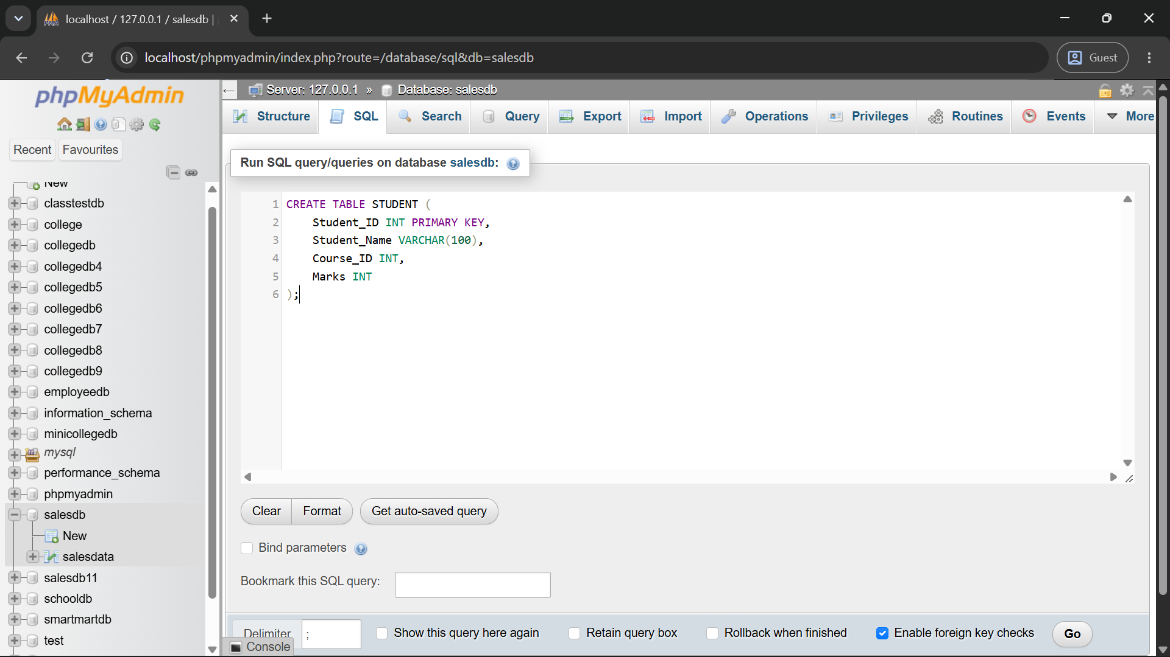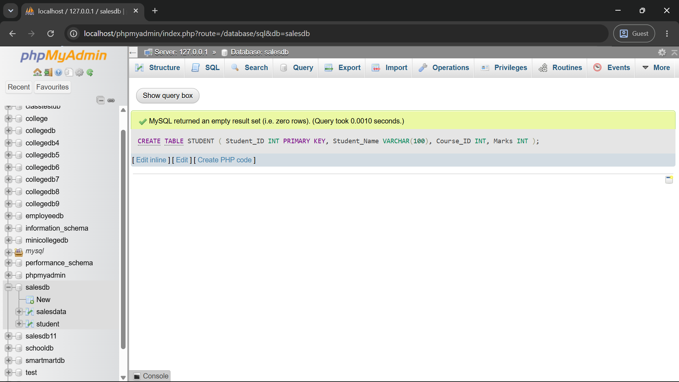
b) SELECT *FROM STUDENT WHERE Marks > 70;
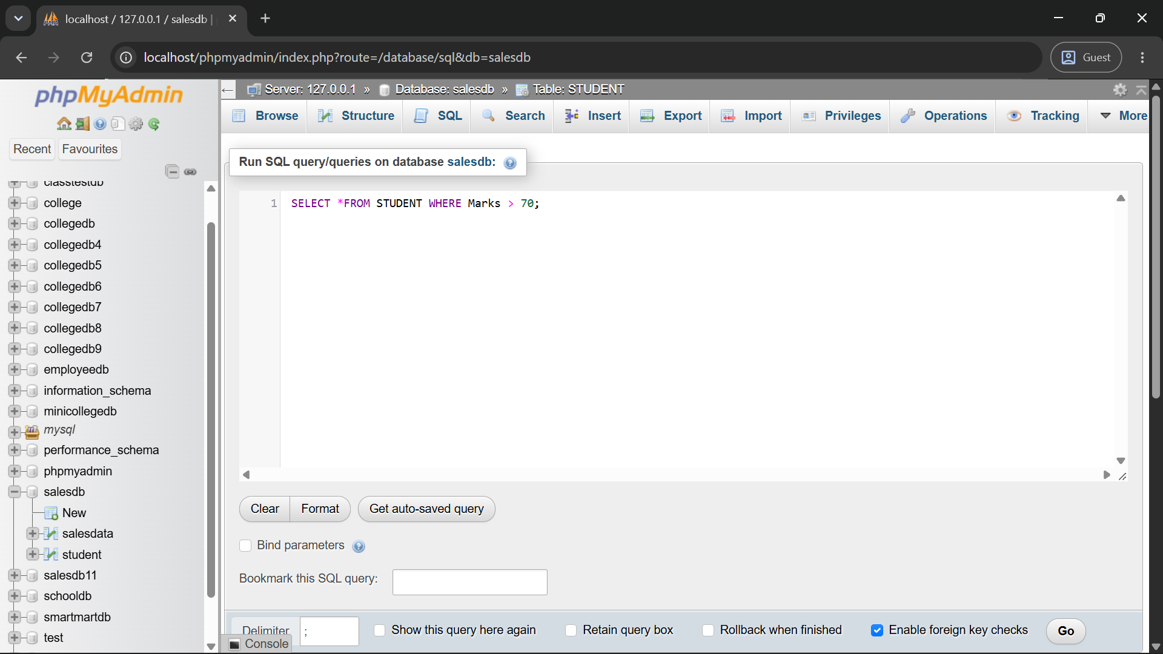
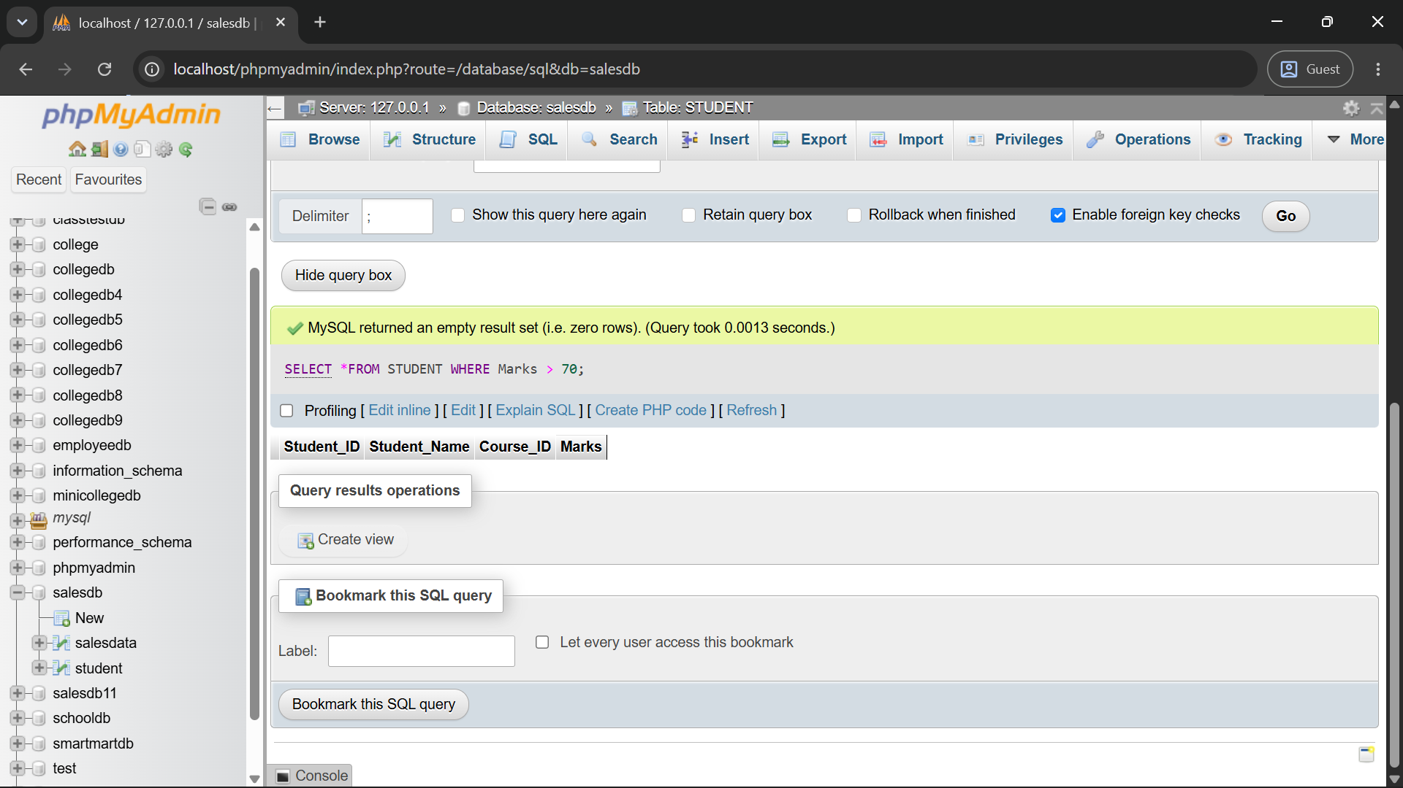
c) SELECT S.Student_Name, C.Course_Name FROM STUDENT S JOIN COURSE C ON S.Course_ID = C.Course_ID;
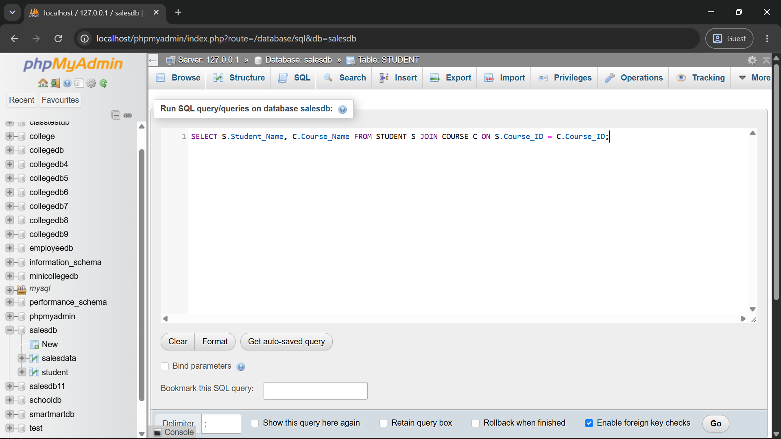
d) SELECT Course_ID, AVG(Marks) AS Average_Marks FROM STUDENT GROUP BY Course_ID;
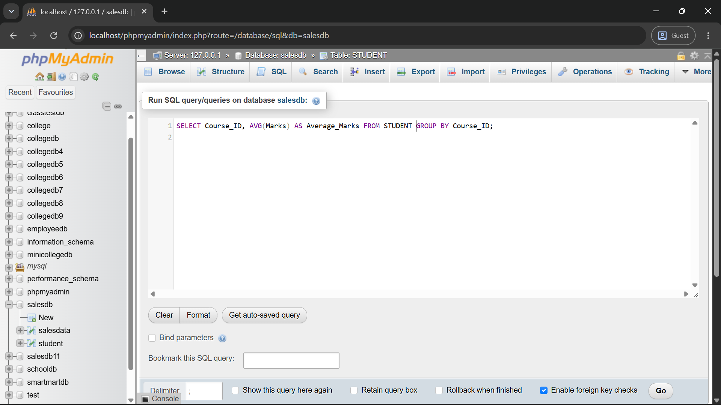
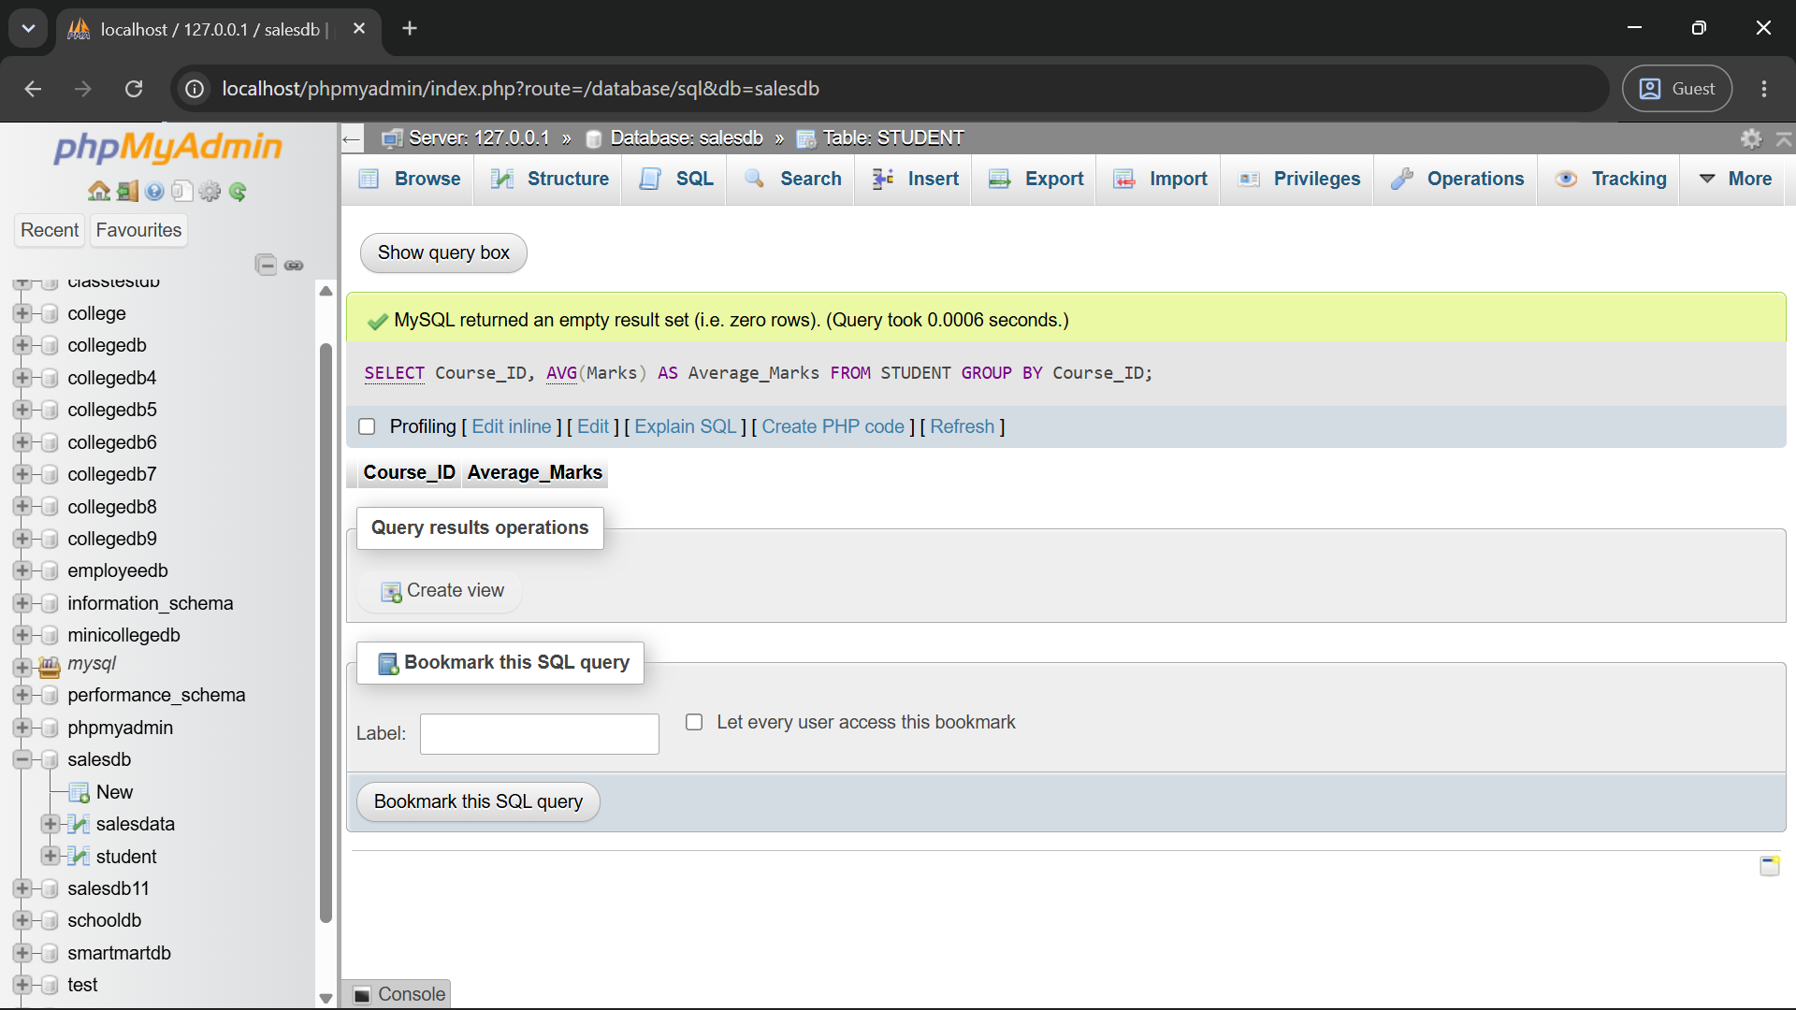
e) SELECT Course_ID, AVG(Marks) AS Average_Marks FROM STUDENT GROUP BY Course_ID HAVING AVG(Marks) > 65;
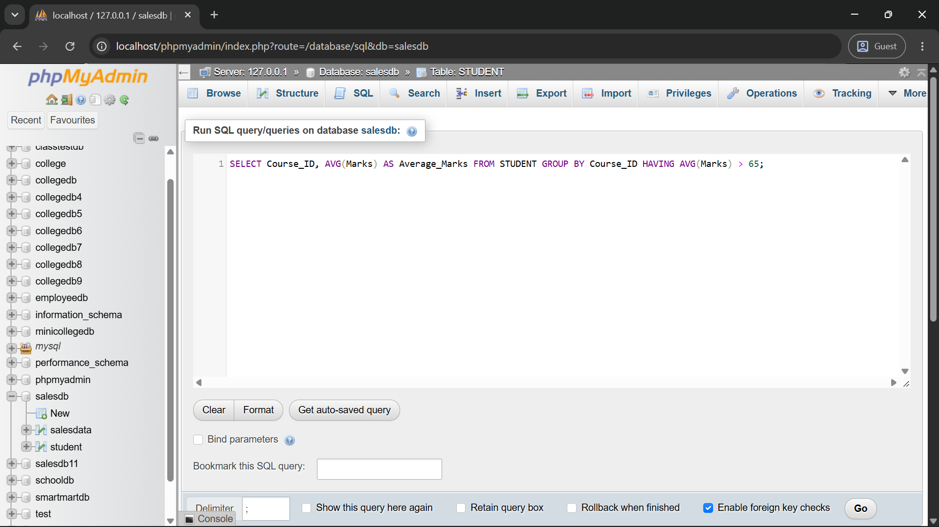
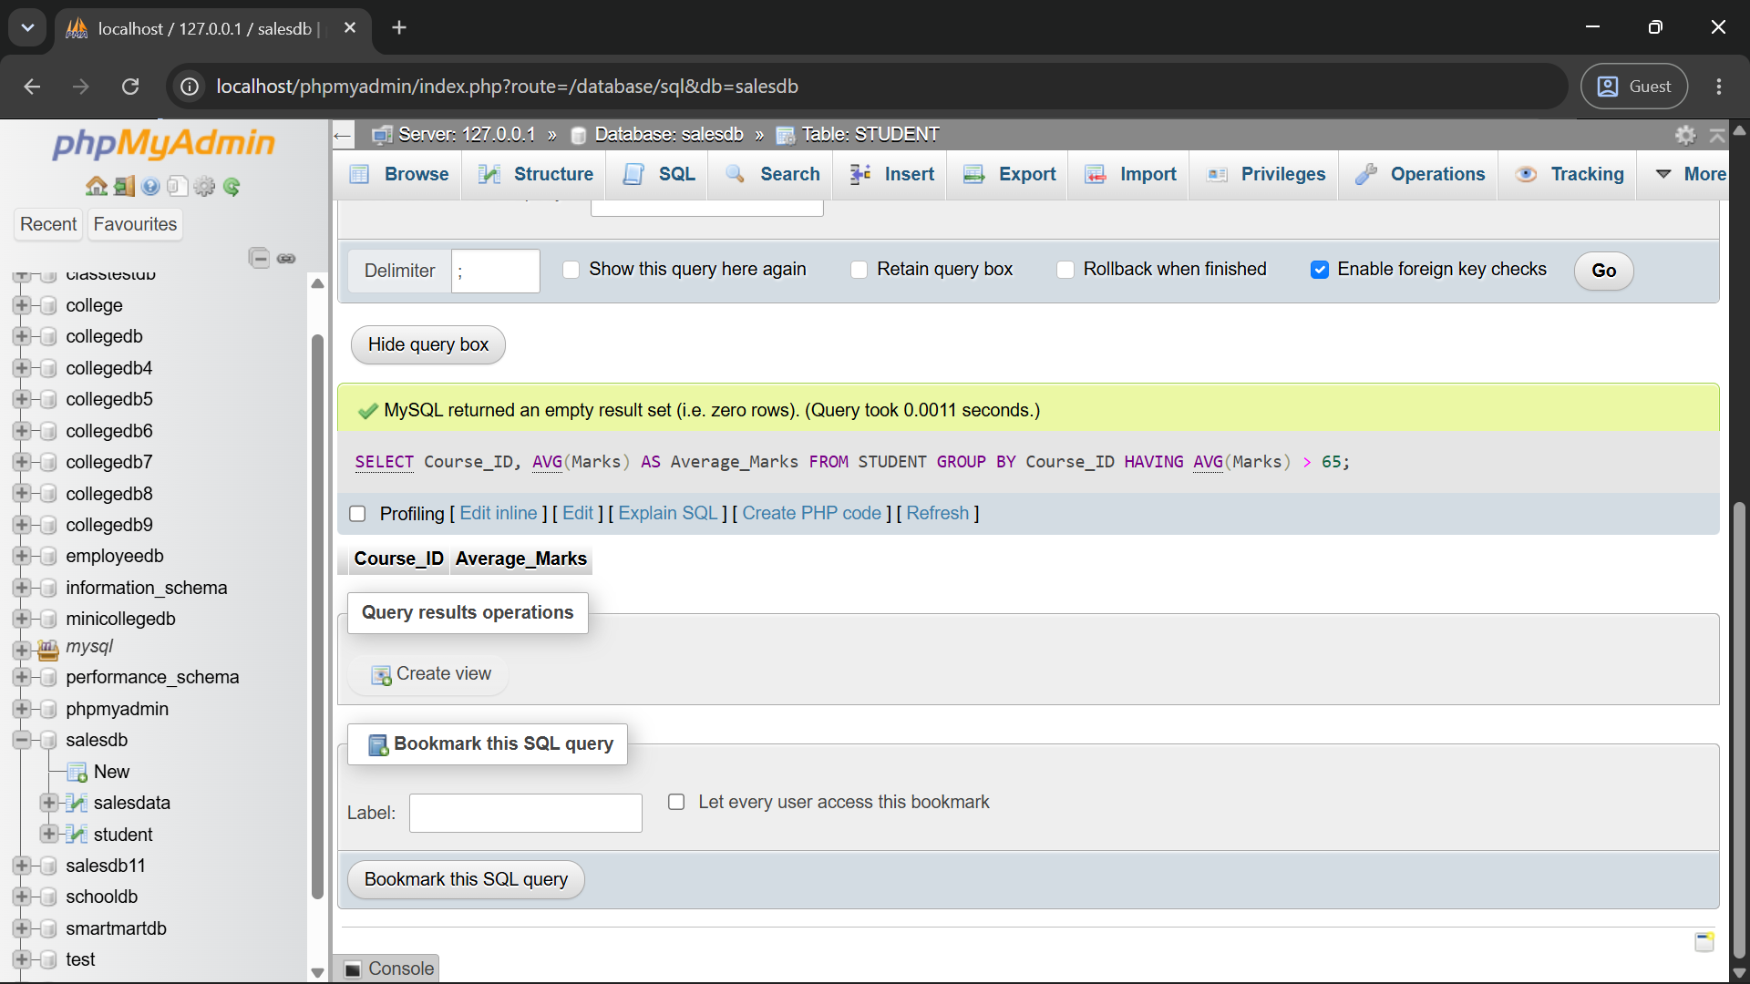

Q2)a) SELECT * FROM EMPLOYEE WHERE Department = 'IT' ORDER BY Salary DESC;
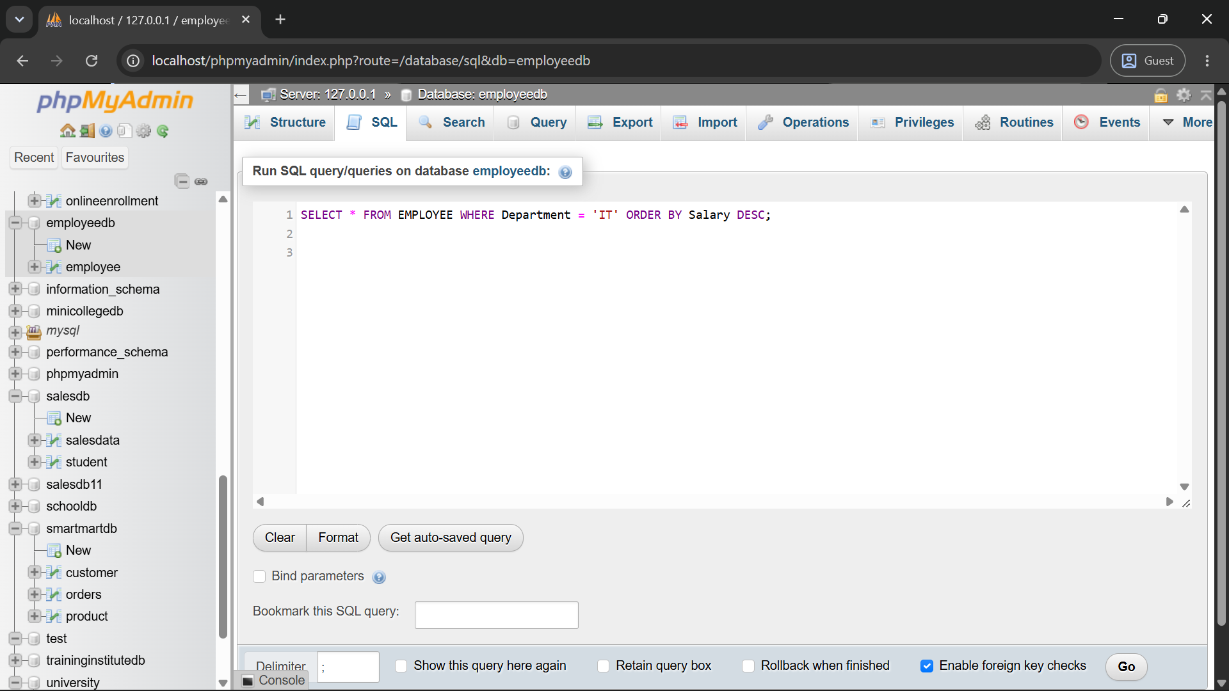
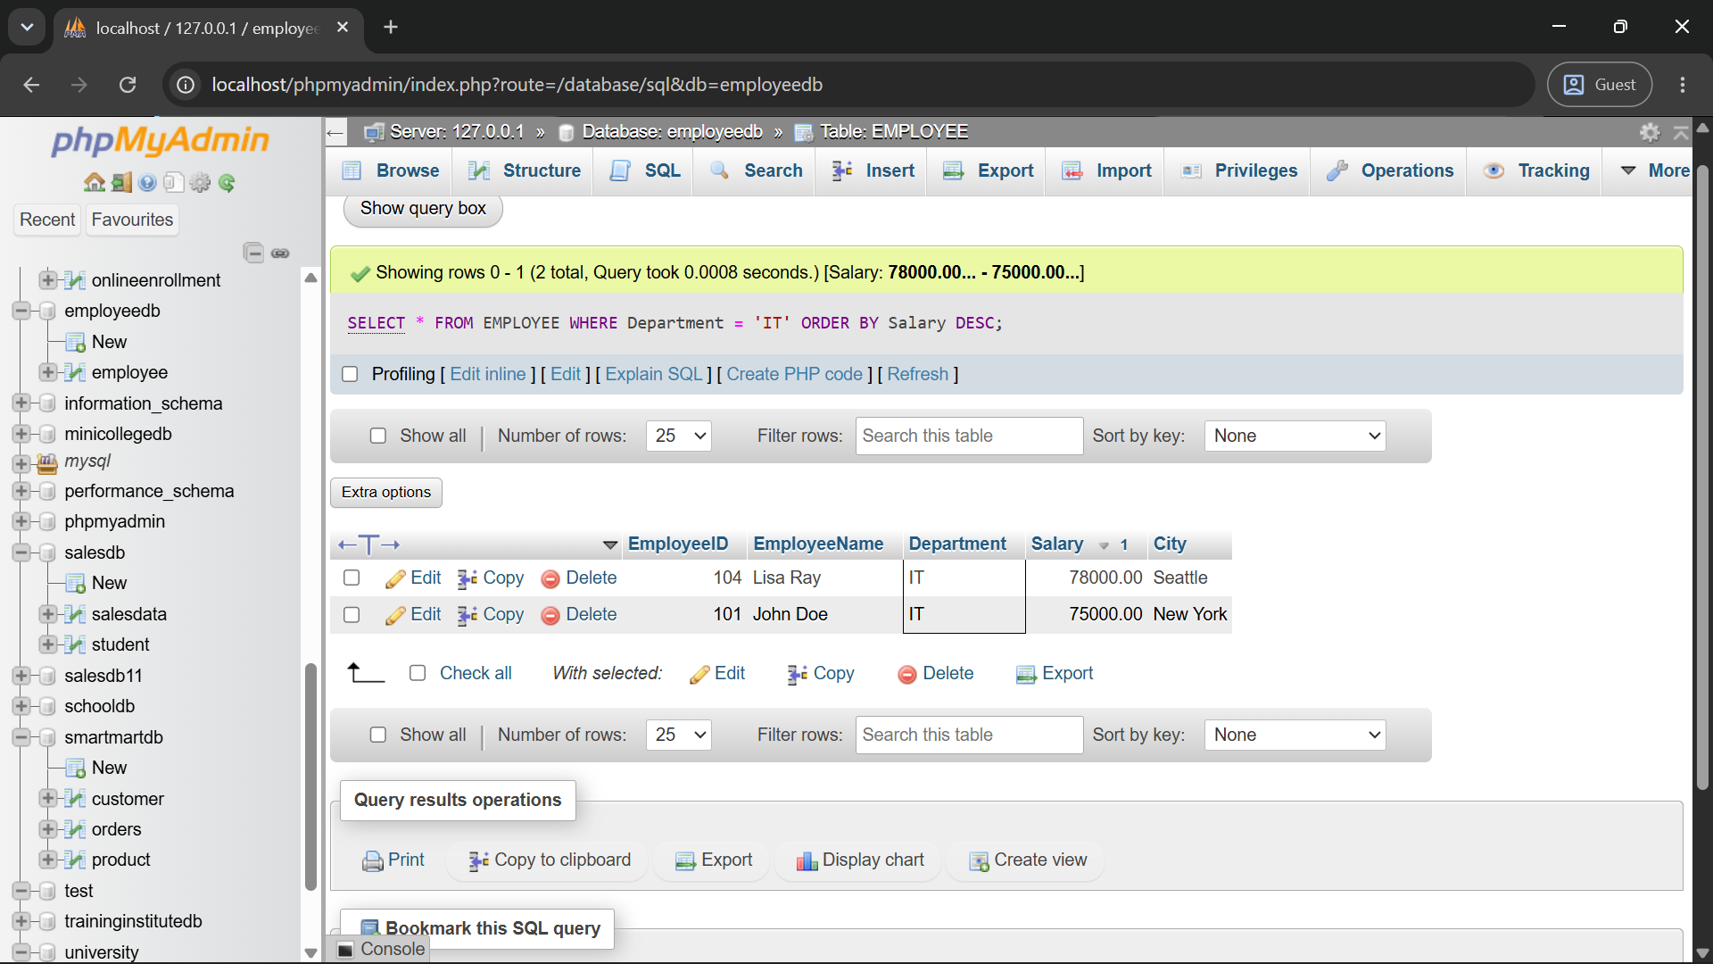
b) SELECT MAX(Salary) AS Highest_Salary FROM EMPLOYEE;
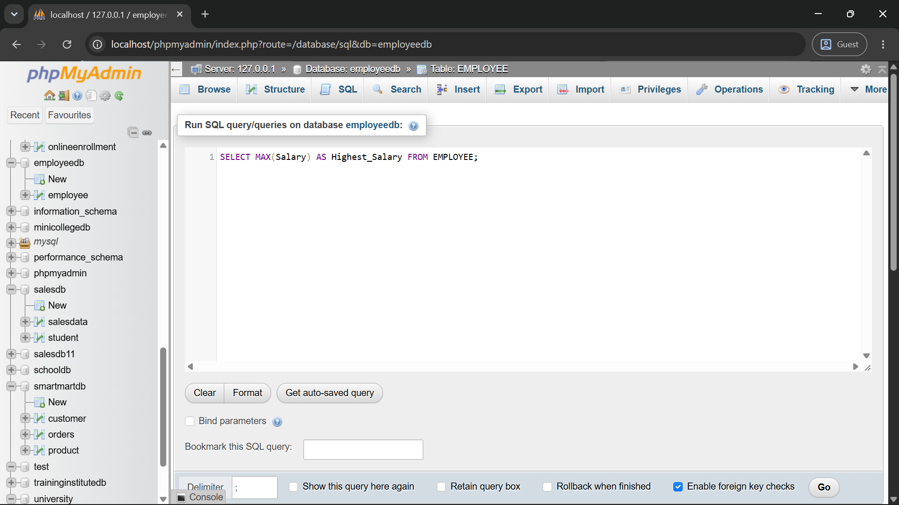
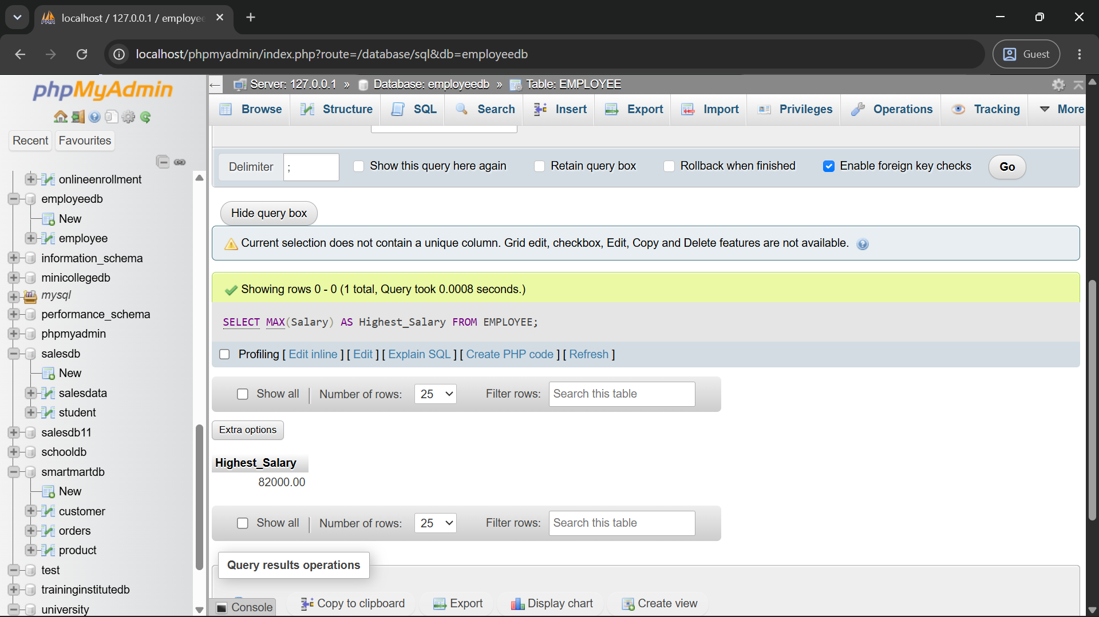
c) SELECT Department, COUNT(*) AS Employee_Count FROM EMPLOYEE GROUP BY Department HAVING COUNT(*) > 3;
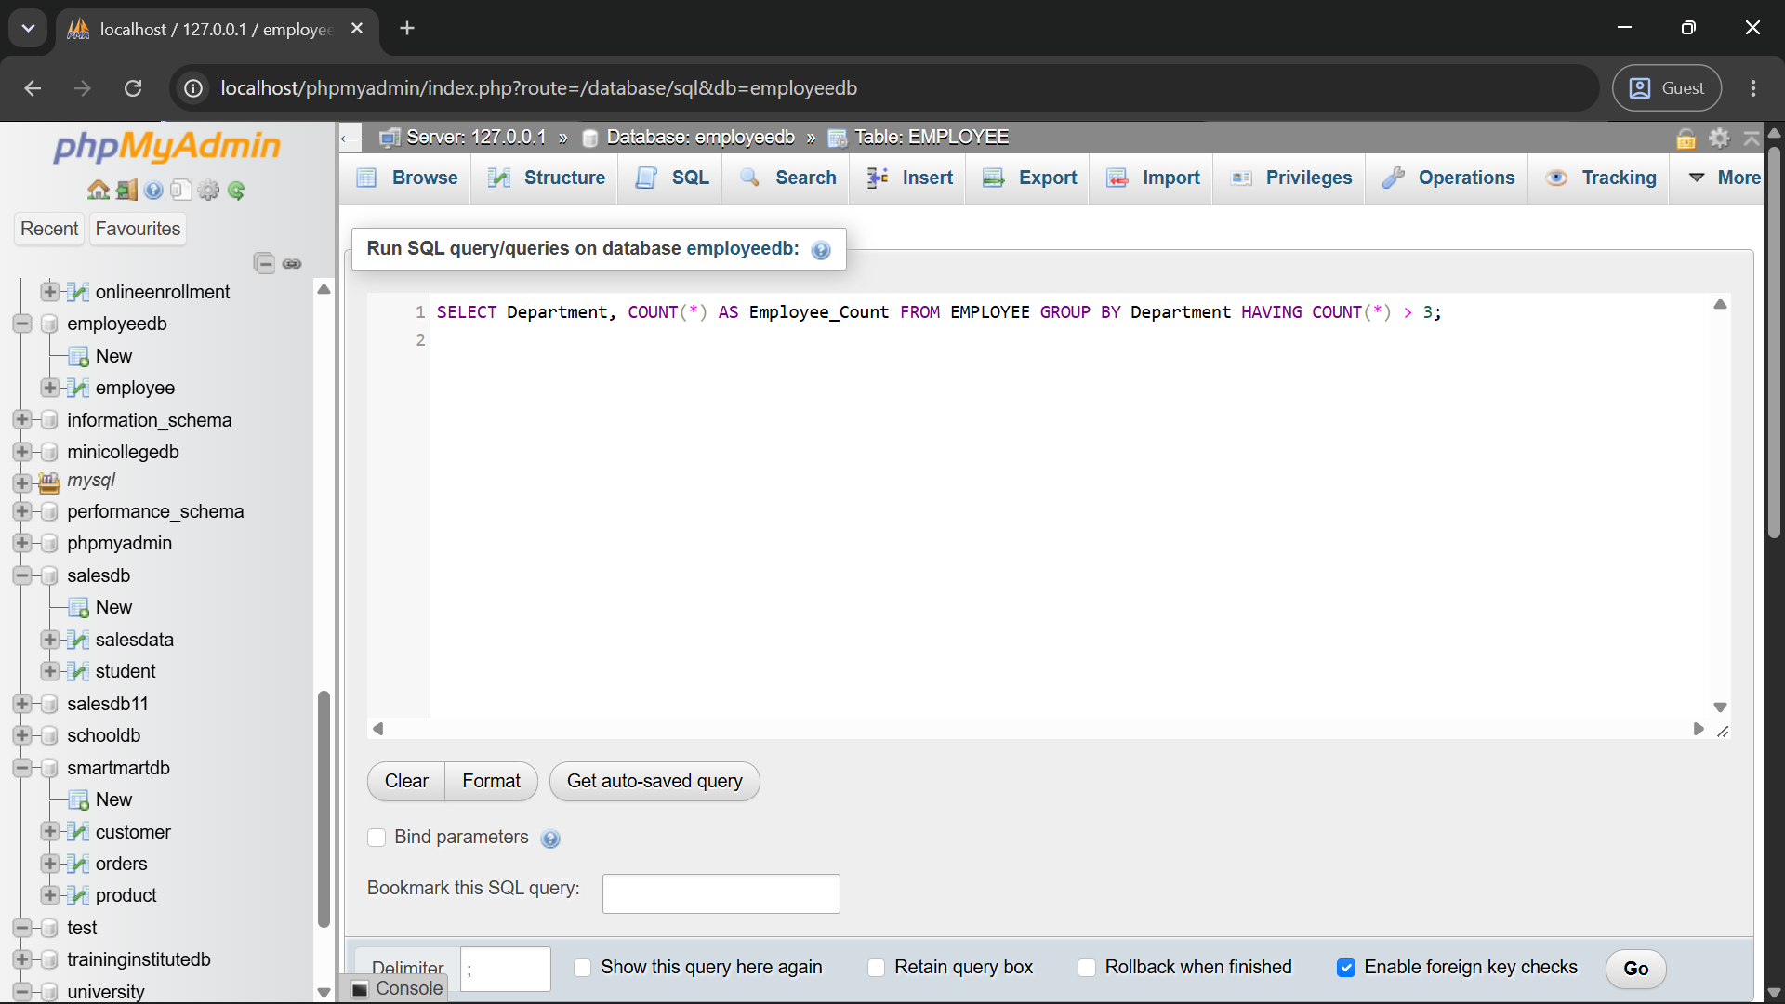
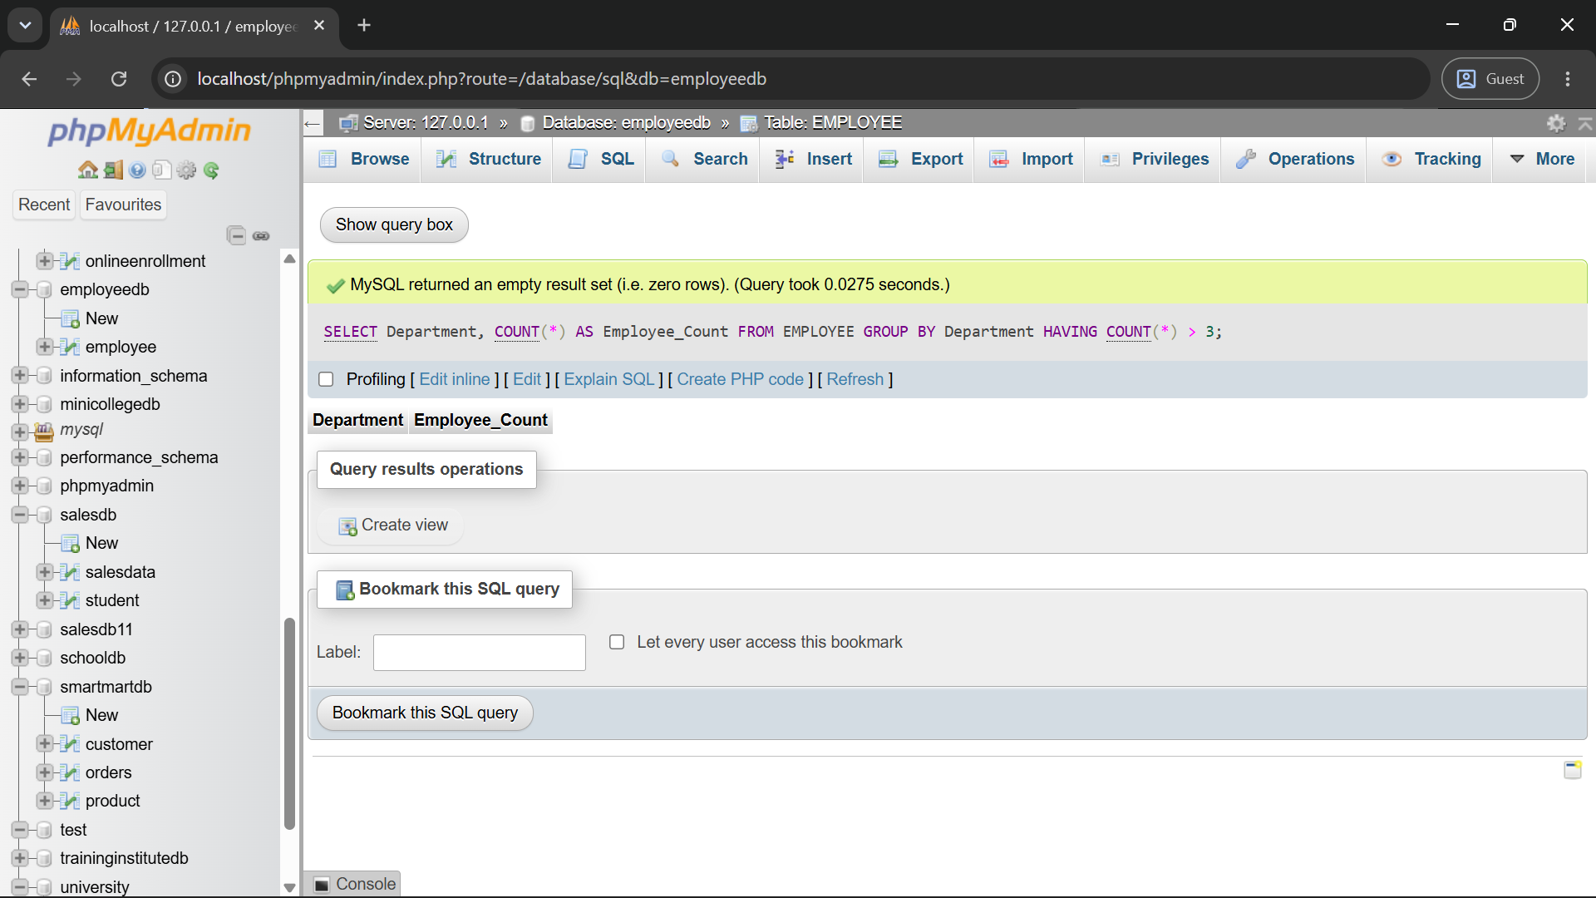
d) SELECT * FROM EMPLOYEE WHERE Salary > (SELECT AVG(Salary) FROM EMPLOYEE);
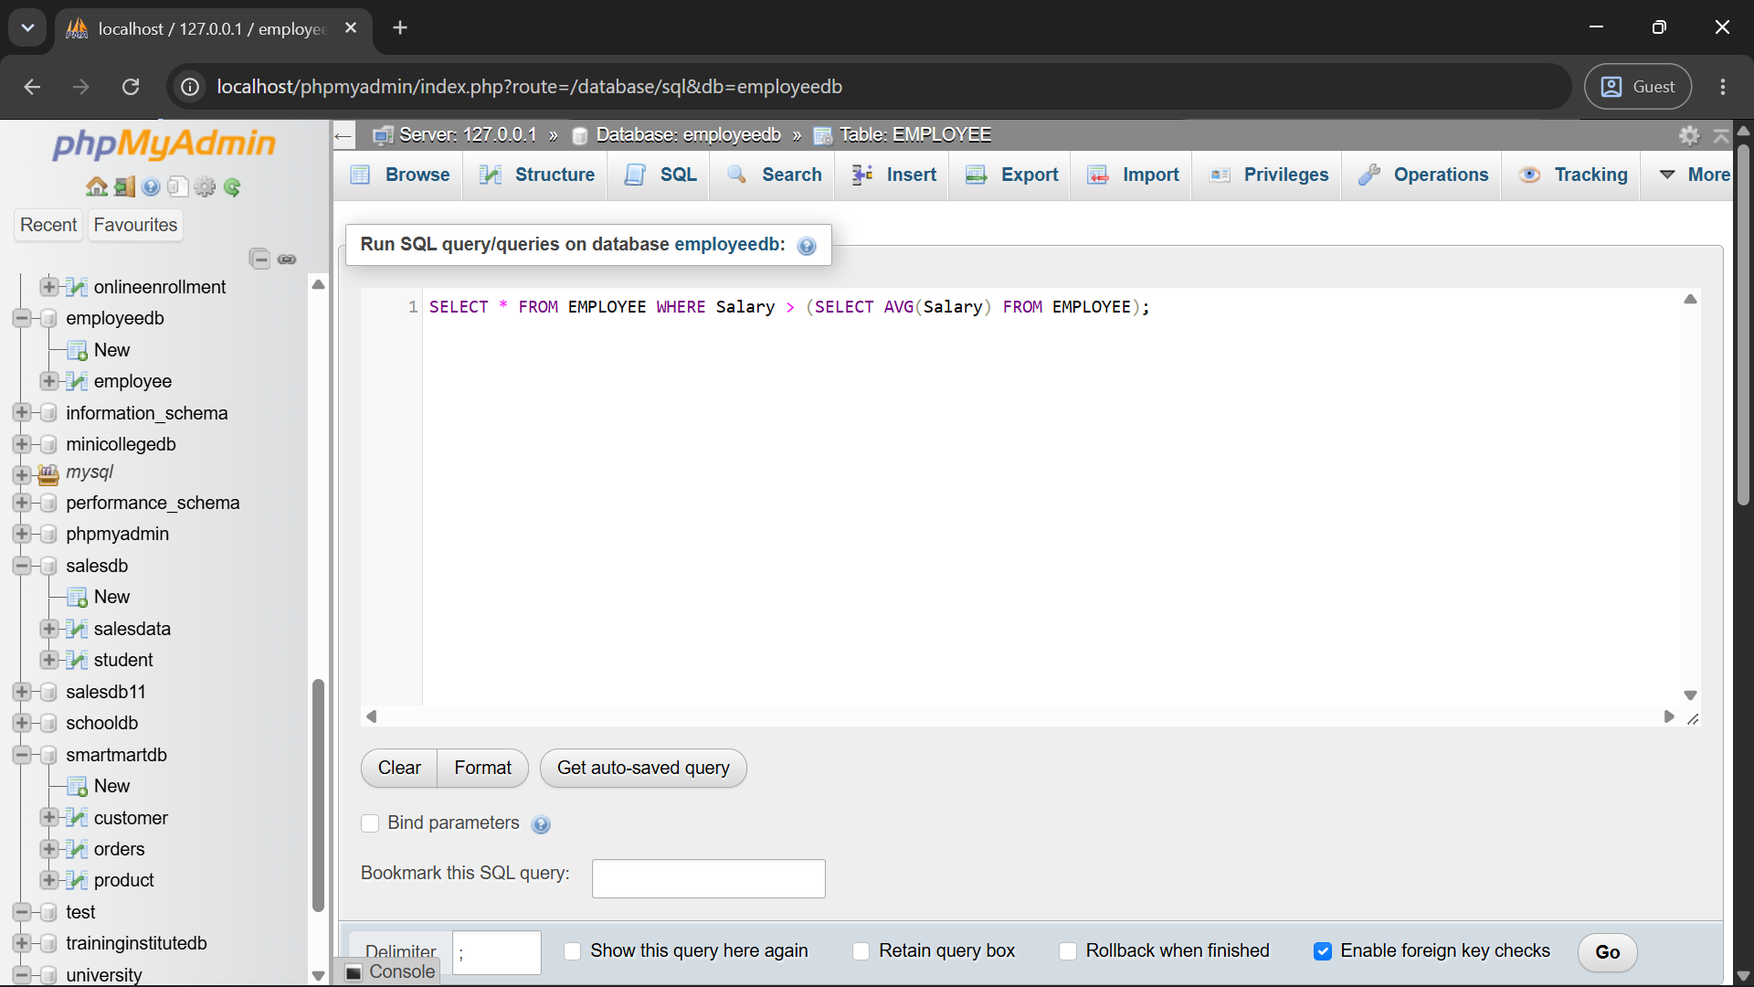
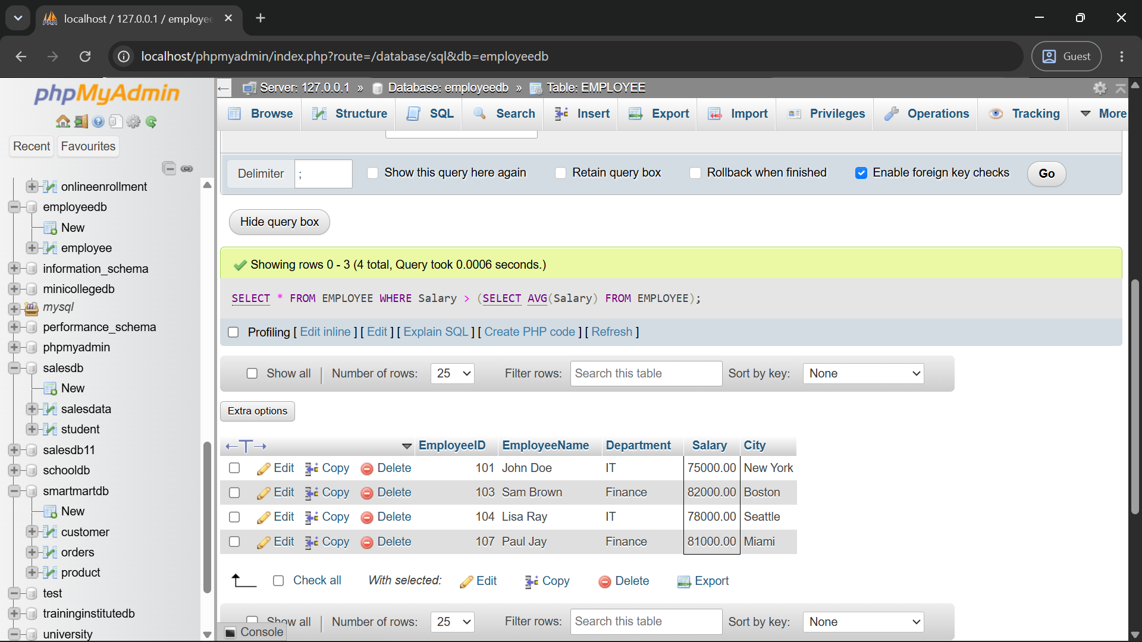
e) CREATE VIEW IT_Employees AS SELECT * FROM EMPLOYEE WHERE Department = 'IT';
